Seasonal Trees
Try and create a 4 seasonal tree.
Look at the examples for each age group and either copy or create your own. Don’t forget you can always do more than one and you could try a lower or higher age group too. With the older age groups feel free to use any media you have at home or even photography!

Nursery - Year 2
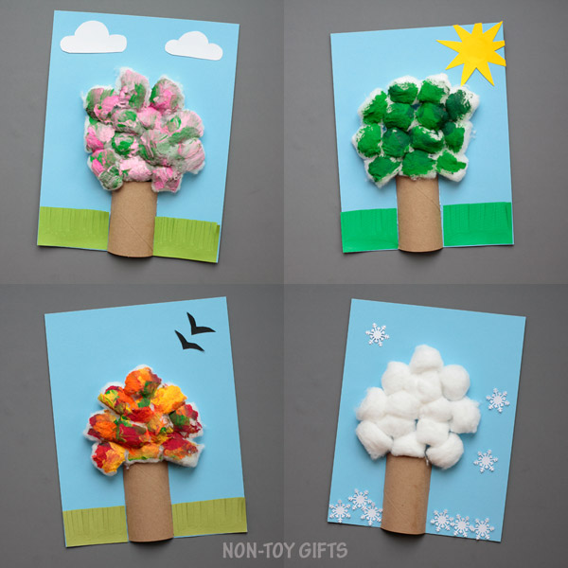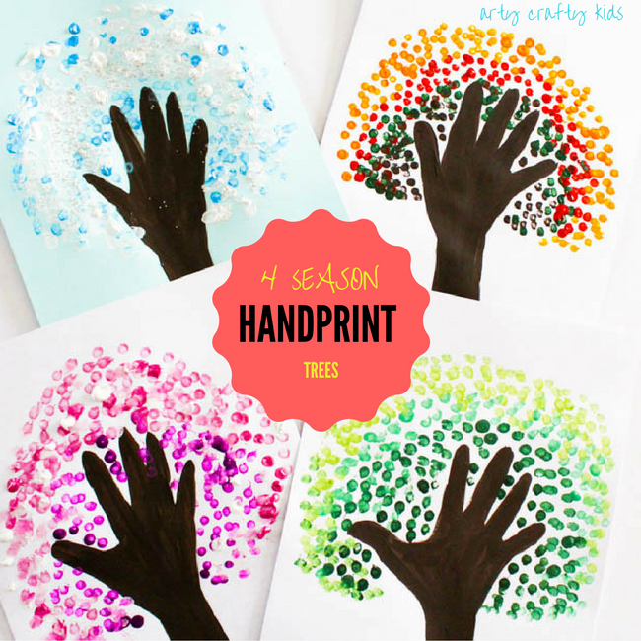

Year 3 - 4
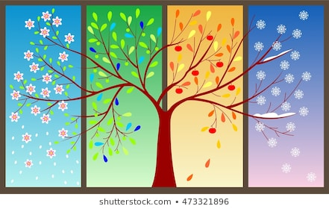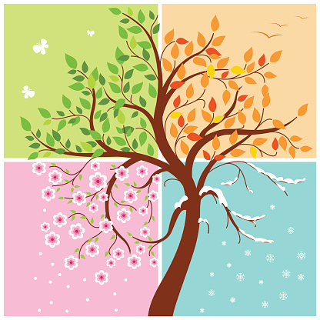

Year 5 – 6 examples:
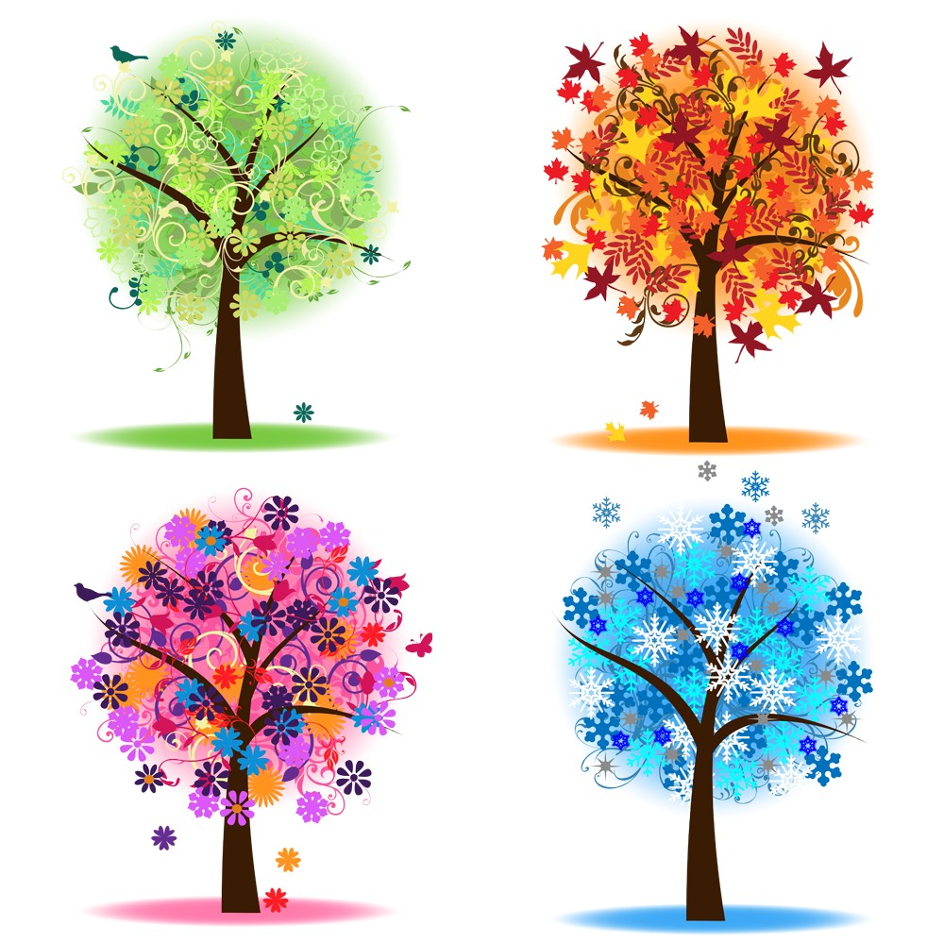
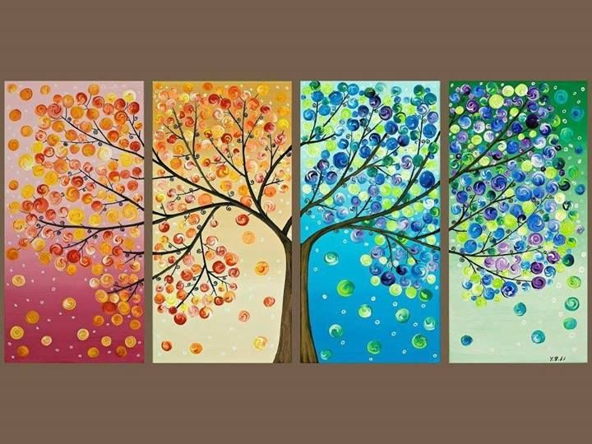

Year 7 - 8
