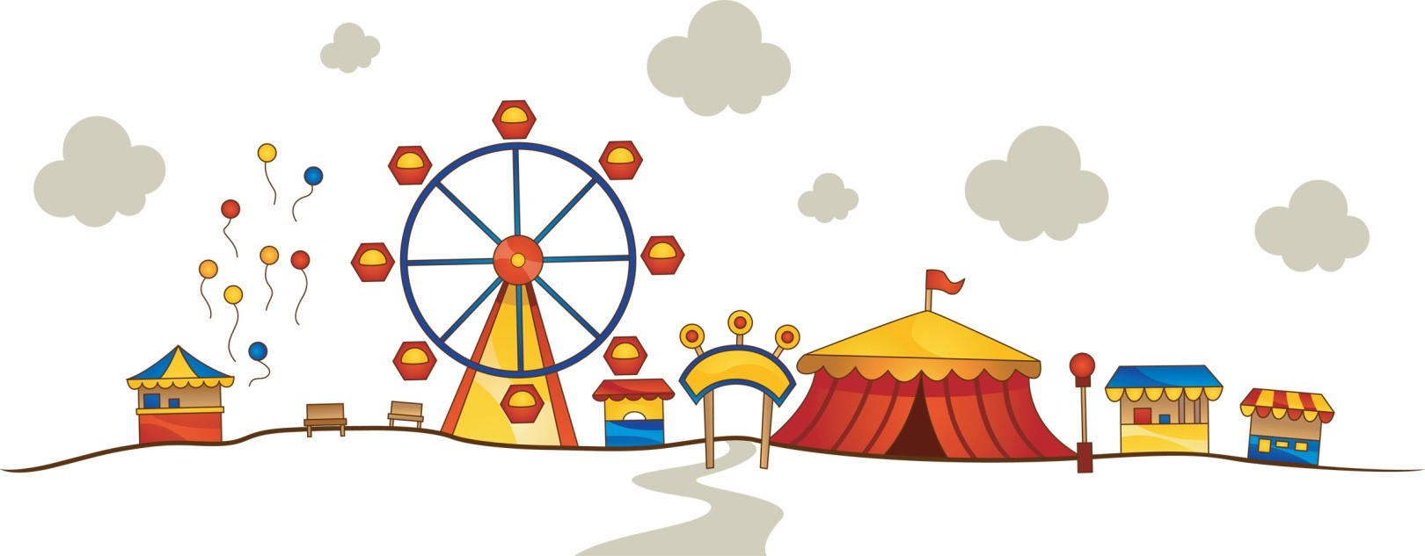

Welcome to Theme Park Maths, a unique investigation which
sees you plan, build and operate a theme park. Your decisions
throughout the investigation will be crucial as to whether you
make a profit or a loss.

Good luck!

Name
___________________

Class
_____________________

The scenario

A plot of land has become available and you have decided to build a brand new theme park.

You have managed to secure a £500 000 loan from the bank

During this activity you will have a range of tasks to complete, from building your theme park, to working out how much it costs to run and most importantly working out how much profit you can make

Task 1
Your first task is to plan your park. Use a piece of squared paper and this will be your park. You must carefully decide what kind of rides you are going to have. You also need to think about the other facilities visitors will need when they come to your theme park. For example, toilets, cafes, shops and paths will all be available for purchase.

Many theme parks have different areas that are ‘themed’. Therefore you might like to have a Wild West American area or a Space area. Think carefully about what you would like to include in yours and make your park the best in the UK.

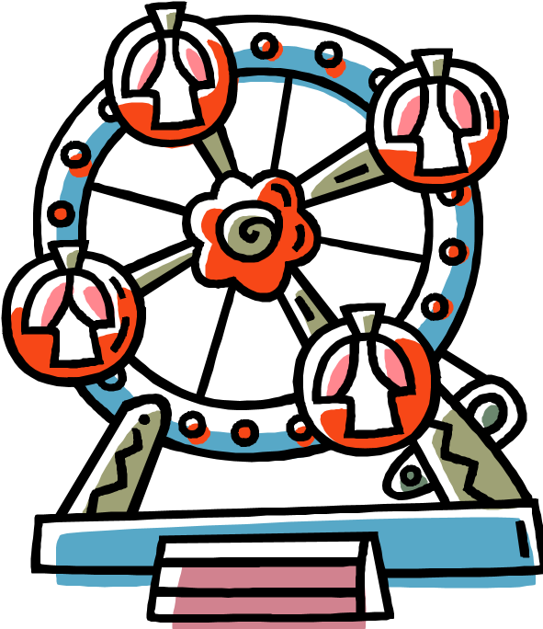

Task 1 – Setting up your theme park.

Your spending limit is £500 000. Design and draw your theme park on squared paper. You must not go over your spending limit and you must have car parks, toilets, and paths to connect all the items, cafes and shops for your visitors. It is not about just having rides. You will need to please all of your visitors

Each attraction comes under a different category. Each category varies in price. Choose carefully from the prices and information page, making sure you have something which appeals to everyone.

Do not draw your theme park – you have to colour in the squares which represent the items you have chosen.

Follow the key below when colouring in the plan of your park.

Theme Park Key
Category 1 Rides: Red
Category 2 Rides: Yellow
Category 3 Facilities: Purple
Bins: Orange
Toilets: Pink
Trees: Green
Lakes: Blue
Picnic Benches: Brown
Paths and Car Park: Grey

Prices

Category 1 Attractions - £50 000 each. These attractions take up 5cm²

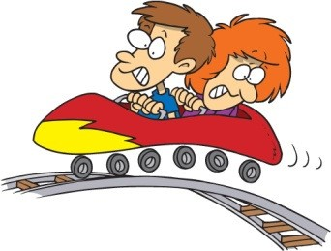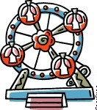
A rollercoaster ^{A water ride} A ferris wheel

Category 2 Attractions - £25 000 each. These attractions take up 4cm²
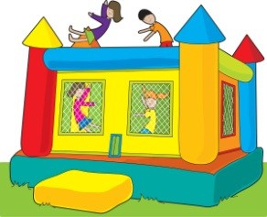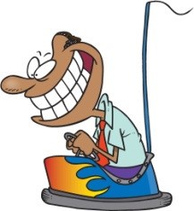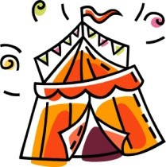
A bouncy castle Dodgems
A Fun House

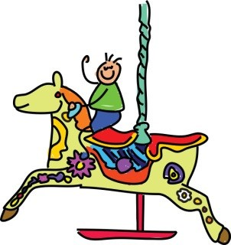
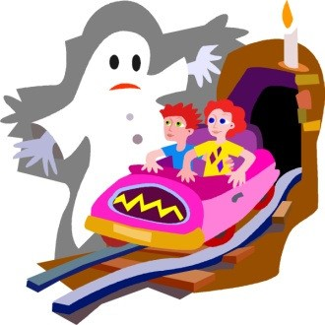
A haunted house Merry-go-round A Carousel Pirate ship
Ghost ride
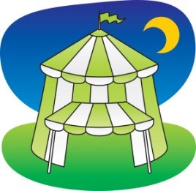
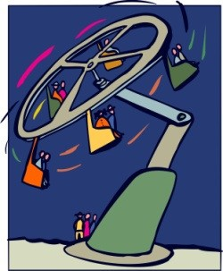
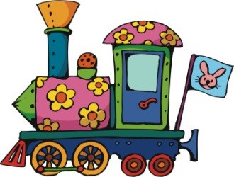
Spinning Ride Circus Tent Train

Category 3 Attractions - £8 000 each. These attractions take up 3cm²

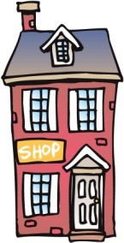
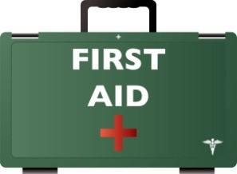
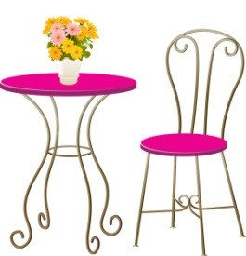
A Cafe A Shop First Aid
Ice-cream Stand

Other facilities and attractions – These items are individually price

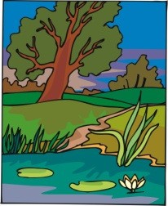
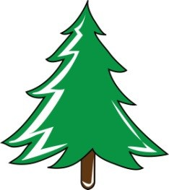
Path - £200 per 5cm length Lake - £1 000 per square

Tree - £200 per square
(1 square per tree)

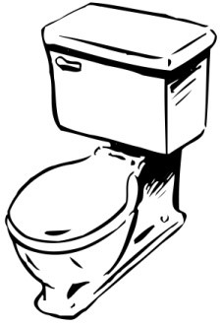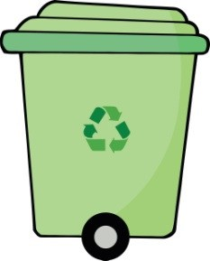

Toilets - £1 000. Rubbish Bin _{1cm² per bin} - £50
2cm² per block of toilets
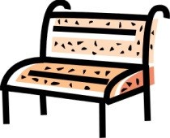  Picnic Benches - £100 per bench per square | Car Park - £500 per square. Each square will take 100 cars

Task 2: Running your theme park

To run your theme park the following costs will apply to each item that you have every day. How much will it cost to run your theme park for one day?

 |  | Costs
Item | Staff Costs | Electricity, Maintenance and  Repairs | Number in park | Total Costs per day
Category 1 Ride (per ride) | £40 a day | £50 a day
Category 2 Ride (per ride) | £30 a day | £30 a day
Category 3  Facility  (per facility) | £20 a day | £20 a day
Toilets (for all toilets) | £5 a day | £5 a day | NA
Bins (for all bins) | £31.50 a week | £5.25 a week
 |  |  | NA
Trees  (for all trees) | £91.25 a year | None | NA
 |  | Totals

Complete the table above.

How much does it cost to open your park for one day? __________________

Extension Activity

What about one week? _________________________

One year? ___________________________

Task 3 – Entry Fee

How much does it cost to open your park each day? _______________ (figure from task 2)

How many visitors do you think you will have each day? (remember it’s a brand new park and not many people know about it yet!)

Make an estimate: __________

Give your plan to a family member or friend, you must not tell them anything about your park. They must use the criteria below to decide your entry fee.

Price Category 1 - £20 per person.
- Four or more category 1 rides
- 10 or more rides in total
- 6+ category 3 facilities
- A first aid centre
- A well set out park with carefully placed bins, benches, toilets and paths.

Price Category 2 - £15 per person.
- Two or more category 1 rides
- 7 or more rides in total
- 4 or more category 3 facilities
- A first aid centre
- Some consideration to where bins, toilets, benches and paths are placed.

Price Category 3 - £10 per person • One or more category 1 rides.
- 5 or more rides in total.
- 2 or more category 3 facilities.
- Some errors in where bins, toilets, benches and paths are placed which may lead to unhappy customers.

Price Category 4 - £5 per person
- At least 3 rides
- At least 1 category 3 facility.
- Some errors in where bins, toilets and paths are placed which may lead to unhappy customers.

Decide on the entry price and enter it here £ __________

Task 4 – How much do you make on the entry fee?

Calculate how much you make each day based on the entry fee you set on the previous page.

Day | Number of visitors | Income | Day | Number of visitors | Income
1 | 50 |  | 16 | 89
2 | 75 |  | 17 | 104
3 | 66 |  | 18 | 130
4 | 49 |  | 19 | 209
5 | 61 |  | 20 | 143
6 | 67 |  | 21 | 99
7 | 102 |  | 22 | 111
8 | 110 |  | 23 | 206
9 | 87 |  | 24 | 350
10 | 21 |  | 25 | 300
11 | 24 |  | 26 | 278
12 | 67 |  | 27 | 453
13 | 66 |  | 28 | 294
14 | 98 |  | 29 | 367
15 | 109 |  | 30 | 359

Task 5 – Profit and Loss

Each visitor to your theme park will spend;

- £4 at each café you have
- £3 at each shop you have
- £1 at every ice cream stand you have
Work out your total profit from the admission price (gate), cafes and shops. Now take away your total costs that you have already worked out and find your profit or loss for each day.

Income

 | Day | Number of  visitors | Admission  (Task 4) | Café | Shop | Ice Cream | Total (a) | Total costs  (Task 2) (b) | Profit (a-b)  A minus B
 | 1 | 50
 | 2 | 75
 | 3 | 66
 | 4 | 49
 | 5 | 61
 | 6 | 67
 | 7 | 102
 | 8 | 110
 | 9 | 87
 | 10 | 21
 | 11 | 24
 | 12 | 67
 | 13 | 66
 | 14 | 98
 | 15 | 109

 | 14 | 98
 | 1515 | 109
 | 16 | 89
 | 17 | 104
 | 18 | 130
 | 19 | 209
 | 20 | 143
 | 21 | 99
 | 22 | 111
 | 23 | 206
 | 24 | 350
 | 25 | 300
 | 26 | 278
 | 27 | 453
 | 28 | 294
 | 29 | 367
 | 30 | 359
Total

What profit or loss have you made in the first month of opening your theme park?

____________________________________________

Task 6 – Finding your Annual Profit

Your monthly profit increases by 10% each month for next 5 months. Calculate you profit for the rest of the year that your park is open for.

Month 1 Profit _________________

Month 2 Profit _________________

Month 3 Profit __________________

Month 4 Profit __________________

Month 5 Profit __________________

Month 6 Profit __________________

First Year Profit _______________________

Money left over after building your theme park ________________ (figure from task 1)

Total in the bank at the end of the first year _________________

