Year 5 History Project
You then have a choice of a few options to work on. If we are closed for longer maybe you’ll have time to work on two!
Task 1- Art work
Have a look through these examples of Aztec art on the PowerPoint on Google Classroom. Create an Aztec style mask using card and anything else you have at home.
The PowerPoint has lots of ideas to help you but here are a couple,
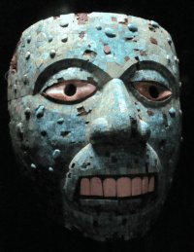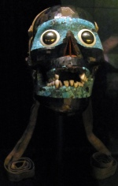

Task 2- The Aztecs in film
If you have Netflix watch the film The Road to Eldorado which depicts the Aztec Empire. Write a page in your book about the film. https://www.netflix.com/title/60000171
- What did you learn about the Aztecs from the film?
- How did it depict them? Good? Bad?
- Do you think it is a reliable source about the Aztecs? Why? Why not?
- Overall was it a good film and why?

Task 3- Aztec recipes
With your parents’ help, have a go at making some of these Aztec style recipes. Create recipe instructions in your books and then a review of the taste and what you thought. Here are a few websites with possible recipe ideas:
https://www.theendlessmeal.com/spicy-aztec-hot-chocolate/print/25347/
https://www.tasteofhome.com/recipes/aztec-vegetables/print/
https://blogs.getty.edu/iris/cook-your-own-aztec-feast/
https://passtheflamingo.com/2017/09/13/ancient-recipe-tlahco-tacos-aztec-prehistory-16th-century-ce/
https://food52.com/recipes/1194-aztec-chocolate-cookies

