Year 6 History Project

Start by watching as many videos as you can at: https://www.bbc.co.uk/bitesize/topics/zqhyb9q
You then have a choice of a few options to work on. If we are closed for longer maybe you’ll have time to work on two!
Task 1- Art work
Have a look through these examples of Art from World War One. You can either:
- Create a propaganda style art piece showing the positive side of the trenches to try and boost morale.
- Create a commemorative style art piece showing what it was truly like and remembering those who gave their lives
With your art work write a response to these questions:
- What are you trying to say about war?
- What details help put your message across?
- Why did you choose your title?
- What impact/effect has war had on the soldiers/people depicted (be sensitive)?
- What can people learn about war from your painting?
- Does the painting provide accurate information which might be useful as a means of recording history?
Commemorative Art Examples
(More examples can be found at: http://www.hmdt.org.uk/hmdtmusic/trenchbrothersteaching/21-creativeresponses/#lightbox/2/ )
Harvest of Battle by Christopher Nevinson (1889–1946) painted in 1921
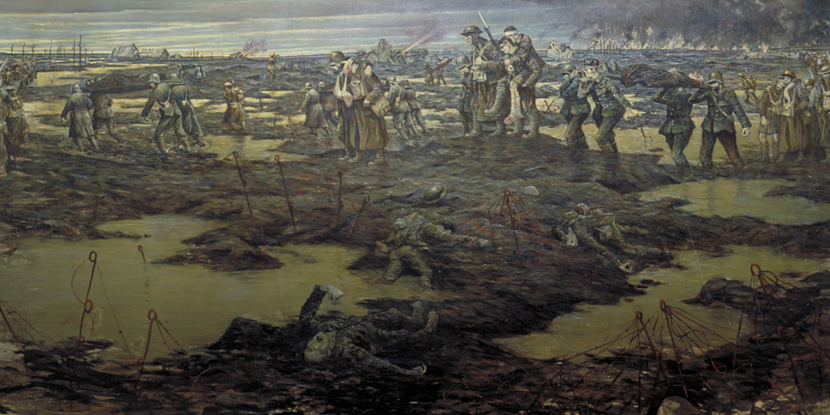

Paths of Glory (1917) by Christopher Nevinson
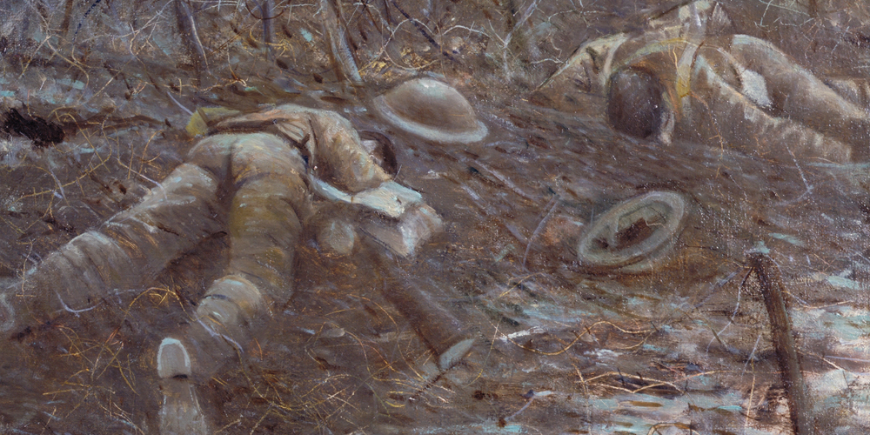
Gassed (1918) by John Singer Sargent
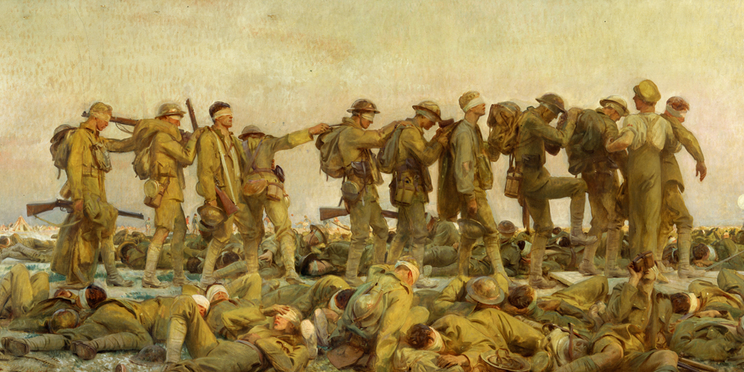
Nurse, wounded soldier and child (1915) by William Hatherell
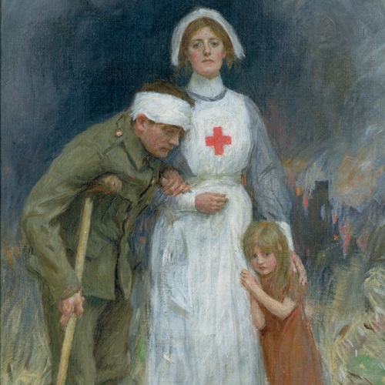
Morale boosting Art Examples
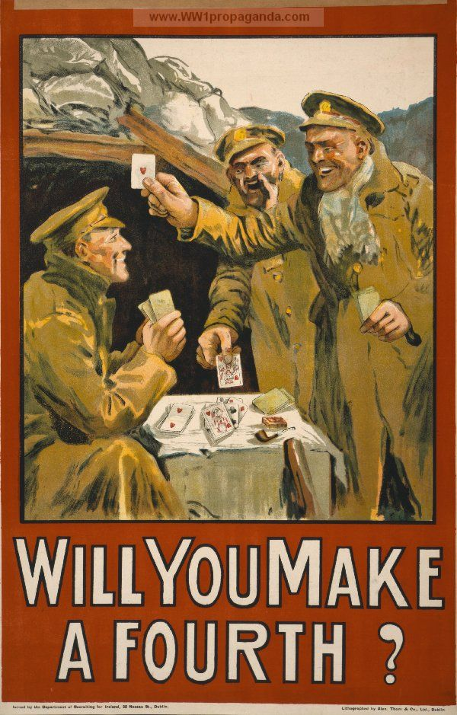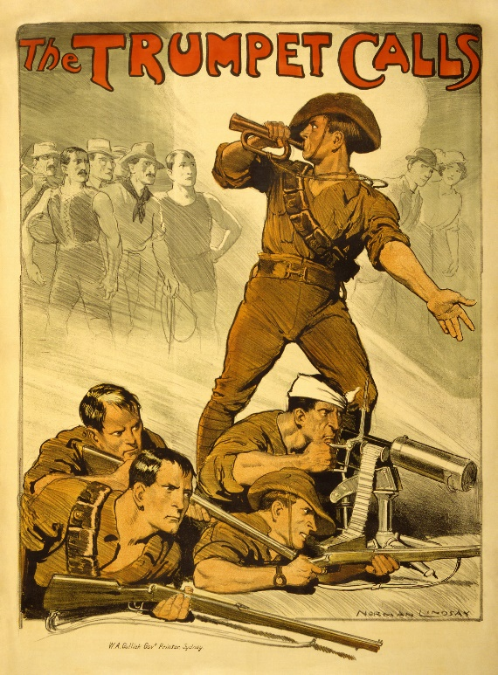

Task 2- Animals in WWI
Michael Morpurgo’s War Horse is a great book showing how animals were used in the First World War. Use these two websites to find out about how animals were used in the war and create a project on it. This could be a poster, a booklet, a word document etc. I have added some examples with photos below.
Videos to watch:
https://www.youtube.com/watch?v=x3VTT9ARr3g
https://www.youtube.com/watch?v=1FMt8uqH5_A
Websites:
http://www.hmdt.org.uk/hmdtmusic/trenchbrothersteaching/18-animals/
https://www.firstworldwar.com/photos/animals.htm

Examples of animals in WWI
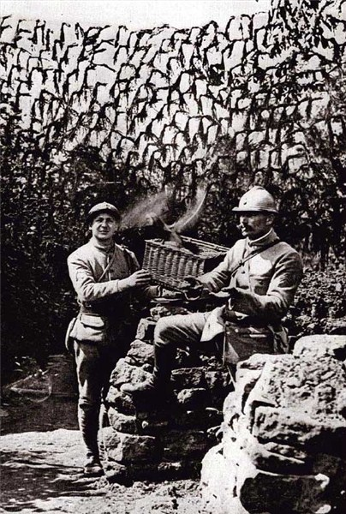 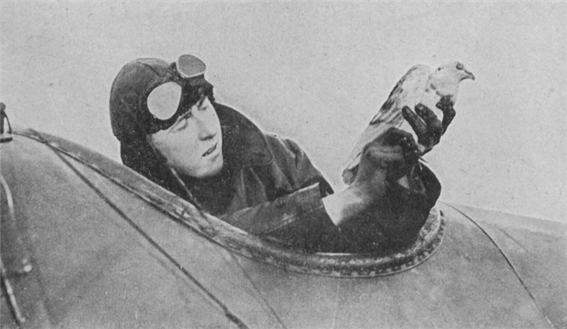Carrier pigeons were used to send messages from trench to trench
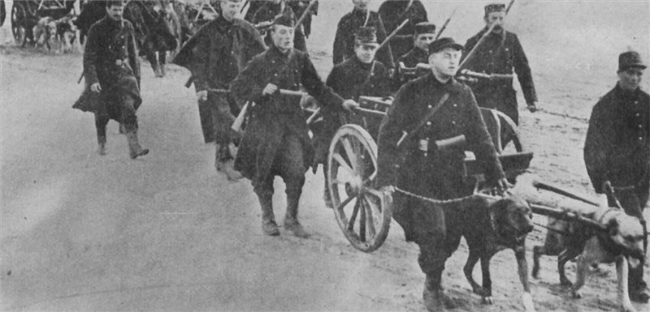
Dogs used by the Belgian army to pull guns and weapons
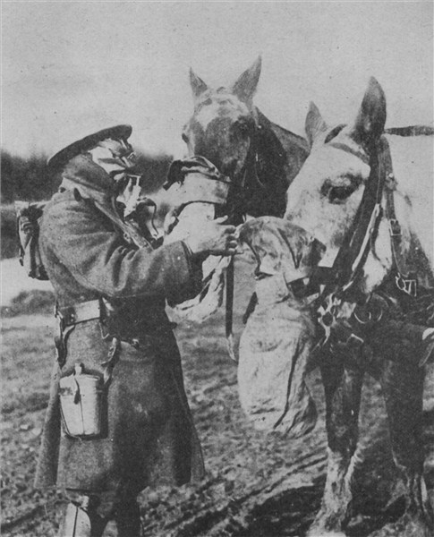
Horse had many roles and often wore gas masks.

Task 3- WWI Weapons
Have a look through the PowerPoint on Google Classroom and the websites below. Create a fact file about the most interesting weapons used a WWI.
http://www.hmdt.org.uk/hmdtmusic/trenchbrothersteaching/9-weaponry-and-equipment/
https://www.bbc.co.uk/bitesize/topics/zqhyb9q/articles/zs666sg

Task 4- Making a periscope
Have a go at making a periscope which would have been used in the trenches. There is a template attached or you can design your own!
