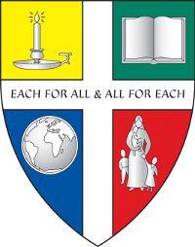
Chesham Preparatory School

Minibus Driver - Part Time, Term Time Only
September 2020

We are an Independent Co-Educational Prep School in Buckinghamshire and are seeking 2 minibus drivers, term time only, to commence as soon as possible.

One role is mornings only, Monday to Friday from 7.30am to 8.30am, the other role is both mornings and afternoons Monday to Friday from 7.00am to 8.30am and 4pm to 5.30pm.

With extremely high standards at Chesham Prep, the successful candidates will be personable and true team players. For insurance reasons candidates must be 25 years of age or older and will have already obtained a D1 driving licence. A copy of the job description and application form is available on our website.

If you are interested in applying for this position, please email Jo Bryant (jbryant@cheshamprep.co.uk) with your completed application form and covering letter.

Chesham Preparatory School, Two Dells Lane Orchard Leigh, Chesham, Bucks, HP5 3QF
Tel: 01494 782619
Chesham Preparatory School is an equal opportunities employer. We are also committed to safeguarding and promoting the welfare of children and young people. Applicants must be willing to undergo child protection screening including checks with former employers and a full DBS.
Charity No 310642.

